**UNIT 4TH MEDIUM ANSWER QUESTIONS (5 MARKS)-**

**Q.(1)Define quality control and its advantages & disadvantages?**

**Ans.**

**Quality control (QC) is a procedure or set of procedures intended to ensure that a manufactured product or performed service adheres to a defined set of quality criteria or meets the requirements of the client or customer. QC is similar to, but not identical with, quality assurance (QA).**

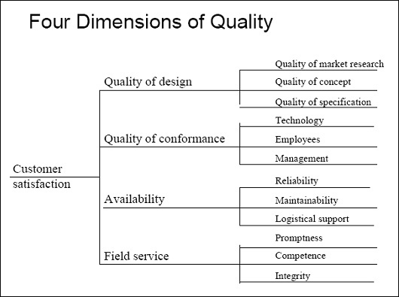

**1. Encourages quality consciousness:**

**The most important advantage derived by introducing quality control is that it develops and encourages quality consciousness among the workers in the factory which is greatly helpful in achieving desired level of quality in the product.**

**2. Satisfaction of consumers:**

**Consumers are greatly benefited as they get better quality products on account of quality control. It gives them satisfaction.**

**3. Reduction in production cost:**

**By undertaking effective inspection and control over production processes and operations, production costs are considerably reduced. Quality control further checks the production of inferior products and wastages thereby bringing down the cost of production considerably.**

**4. Most effective utilization of resources:**

**Quality control ensures maximum utilization of available resources thereby minimizing wastage and inefficiency of every kind.**

**5. Reduction in inspection costs:**

**Quality control brings about economies in inspection and considerably reduces cost of inspection.**

**6. Increased goodwill:**

**By producing better quality products and satisfying customer’s needs, quality control raises the goodwill of the concern in the minds of people. A reputed concern can easily raise finances from the market.**

**7. Higher morale of employees:**

**An effective system of quality control is greatly helpful in increasing the morale of employees, and they feel that they are working in the concern producing better and higher quality products.**

**8. Improved employer-employee relations:**

**Quality control develops to better industrial atmosphere by increasing morale of employees which ensures cordial employer-employee relations leading to better understanding and closeness between them.**

**Q.(2)Define elements of TQM?**

**Ans.** **Total Quality Management (TQM) is a management approach that originated in the 1950s and has steadily become more popular since the early 1980s. Total quality is a description of the culture, attitude and organization of a company that strives to provide customers with products and services that satisfy their needs. The culture requires quality in all aspects of the company’s operations, with processes being done right the first time and defects and waste eradicated from operations.**

**To be successful implementing TQM, an organization must concentrate on the eight key elements:**

1. **Ethics**
2. **Integrity**
3. **Trust**
4. **Training**
5. **Teamwork**
6. **Leadership**
7. **Recognition**
8. **Communication**

**1. Ethics – Ethics is the discipline concerned with good and bad in any situation. It is a two-faceted subject represented by organizational and individual ethics. Organizational ethics establish a business code of ethics that outlines guidelines that all employees are to adhere to in the performance of their work. Individual ethics include personal rights or wrongs.**

**2. Integrity – Integrity implies honesty, morals, values, fairness, and adherence to the facts and sincerity. The characteristic is what customers (internal or external) expect and deserve to receive. People see the opposite of integrity as duplicity. TQM will not work in an atmosphere of duplicity.**

**3. Trust – Trust is a by-product of integrity and ethical conduct. Without trust, the framework of TQM cannot be built. Trust fosters full participation of all members. It allows empowerment that encourages pride ownership and it encourages commitment. It allows decision making at appropriate levels in the organization, fosters individual risk-taking for continuous improvement and helps to ensure that measurements focus on improvement of process and are not used to contend people. Trust is essential to ensure customer satisfaction. So, trust builds the cooperative environment essential for TQM.**

**4. Training – Training is very important for employees to be highly productive. Supervisors are solely responsible for implementing TQM within their departments, and teaching their employees the philosophies of TQM. Training that employees require are interpersonal skills, the ability to function within teams, problem solving, decision making, job management performance analysis and improvement, business economics and technical skills. During the creation and formation of TQM, employees are trained so that they can become effective employees for the company.**

**5. Teamwork – To become successful in business, teamwork is also a key element of TQM. With the use of teams, the business will receive quicker and better solutions to problems. Teams also provide more permanent improvements in processes and operations. In teams, people feel more comfortable bringing up problems that may occur, and can get help from other workers to find a solution and put into place. There are mainly three types of teams that TQM organizations adopt:**

**6. Leadership – It is possibly the most important element in TQM. It appears everywhere in organization. Leadership in TQM requires the manager to provide an inspiring vision, make strategic directions that are understood by all and to instill values that guide subordinates. For TQM to be successful in the business, the supervisor must be committed in leading his employees. A supervisor must understand TQM, believe in it and then demonstrate their belief and commitment through their daily practices of TQM.**

**7. Communication – It binds everything together. Starting from foundation to roof of the TQM house, everything is bound by strong mortar of communication. It acts as a vital link between all elements of TQM. Communication means a common understanding of ideas between the sender and the receiver. The success of TQM demands communication with and among all the organization members, suppliers and customers. Supervisors must keep open airways where employees can send and receive information about the TQM process. Communication coupled with the sharing of correct information is vital. For communication to be credible the message must be clear and receiver must interpret in the way the sender intended.**

**8. Recognition – Recognition is the last and final element in the entire system. It should be provided for both suggestions and achievements for teams as well as individuals. Employees strive to receive recognition for themselves and their teams. Detecting and recognizing contributors is the most important job of a supervisor. As people are recognized, there can be huge changes in self-esteem, productivity, quality and the amount of effort exhorted to the task at hand.**

**Q.(3)Define various types of control charts?**

**Ans.**

**The control chart is a graph used to study how a process changes over time. Data are plotted in time order. A control chart always has a central line for the average, an upper line for the upper control limit and a lower line for the lower control limit.**

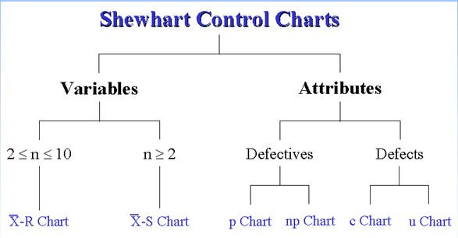

#### Control charts fall into two categories: Variable and Attribute Control Charts.

* **Variable data are data that can be measured on a continuous scale such as a thermometer, a weighing scale, or a tape rule.**
* **Attribute data are data that are counted, for example, as good or defective, as possessing or not possessing a particular characteristic.**

**IMPORTANCE OF CONTROL CHARTS-**

* **Process control can be virtually impossible without some sort of reliable system in place for identifying and understanding the variations in your business processes.**
* **A control chart can help you identify these variations and see how you can use them for future improvements.**
* **The key benefit to control charts, and what makes them so crucial to**[**Six Sigma**](http://www.sixsigmaonline.org/six-sigma-training-certification-information/)**, is that they help you distinguish process variation attributed to assignable causes versus those caused by un assignable causes.**

**Q.(4)Define TQM in detail?**

**Ans.**

**Total Quality Management (TQM) is a management approach that originated in the 1950s and has steadily become more popular since the early 1980s. Total quality is a description of the culture, attitude and organization of a company that strives to provide customers with products and services that satisfy their needs.**

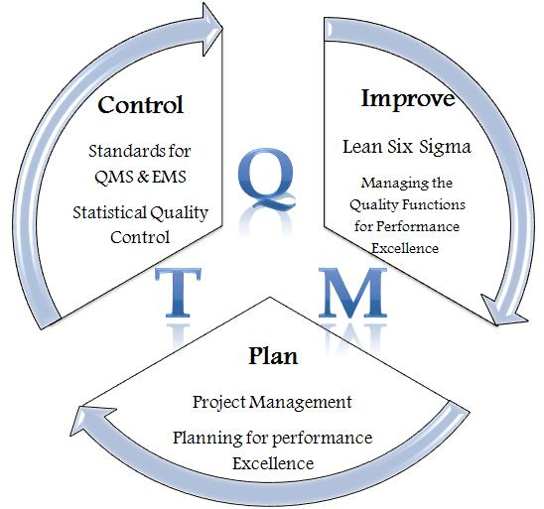

**Five Principles of TQM**

**In order to exceed customer expectations, an organization must embrace five principles:**

* **Produce quality work the first time**
* **Focus on the customer**
* **Have a strategic approach to improvement**
* **Improve continuously**
* **Encourage mutual respect and teamwork**
* **Producing quality work (the first time)-means quality is built into the processes for producing products or providing services, and continual measures are taken to ensure the processes work every time. Employees are empowered to make decisions to improve a process and are provided with continual training to develop their skills.**
* **Focusing on the customer -involves designing products or services that meet or exceed the customer's expectations. This involves the product itself, its functionality, attributes, convenience and even the means by which the information about a product is received by a client.**
* **Having a strategic approach to improvement- processes are developed and tested to ensure the product or service's quality. This also involves making sure suppliers offer quality supplies needed to produce products.**
* **Improving continuously- means always analyzing the way work is being performed to determine if more effective or efficient ways possible, making improvements and striving for excellence all the time are.**
* **Encouraging mutual respect and teamwork- is important because it fosters a single-organizational culture of excellence by knowing that every employee from top to bottom of the hierarchy holds the same core principles at heart.**

**Q.(5)Define SQC in detail?**

**Ans.**

**Statistical process control (SPC) is a method of quality control which uses statistical methods. SPC is applied in order to monitor andcontrol a process. Monitoring and controlling the process ensures that it operates at its full potential.**

**Objective of Statistical Quality Control   
  
Quality Control is very important for a every company. Quality control includes service quality given to customer, company management leadership, commitment of management, continuous improvement, fast response, actions based on facts, employee participation and a quality driven culture.  
  
The main objectives of the quality control module are to control of material reception, internal rejections, clients, claims, providers and evaluations of the same corrective actions are related to their follow-up. These systems and methods guide all quality activities. The development and use of performance indicators is linked, directly or indirectly, to customer requirements and satisfaction, and to management.**

**Statistical Quality Control monitoring and investigating tools include:**

* [**Histograms**](http://www.itl.nist.gov/div898/handbook/eda/section3/histogra.htm)
* **Check Sheets**
* **Pareto Charts**
* **Cause and Effect Diagrams**
* **Defect Concentration Diagrams**
* [**Scatter Diagrams**](http://www.itl.nist.gov/div898/handbook/eda/section3/scatterp.htm)
* [**Control Charts**](http://www.itl.nist.gov/div898/handbook/pmc/section3/pmc3.htm)

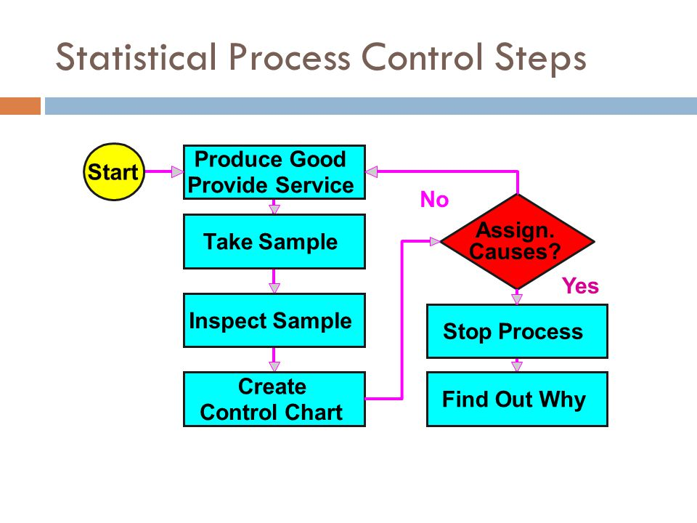

**STATISTICAL PROCESS CONTROL STEPS-**

* **Plan involves using**[**SPC tools**](http://www.winspc.com/what-is-spc/spc-tools)**to help you identify problems and possible causes.**
* **Do involve making changes to correct or improve the situation.**
* **Studyinvolves examining the effect of the changes (with the help of**[**control charts**](http://www.winspc.com/what-is-spc/control-charts-and-other-charts)**).**
* **Actinvolves, if the result is successful, standardizing the changes and then working on further improvements or, if the outcome is not successful, implementing other corrective actions.**

**Q.(6)What is sampling and various types of sampling?**

**Ans.**

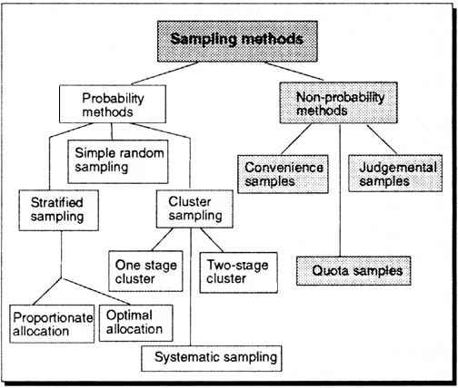

**Sampling is the process of selecting units (e.g., people, organizations) from a population of interest so that by studying the sample we may fairly generalize our results back to the population from which they were chosen. Let's begin by covering some of the key terms in sampling like "population" and "sampling frame."**

**There are five types of sampling: Random, Systematic, Convenience, Cluster, and Stratified. Random sampling is analogous to putting everyone's name into a hat and drawing out several names. Each element in the population has an equal chance of occurring.**

**Sampling Methods can be classified into one of two categories:**

* **Probability Sampling: Sample has a known probability of being selected**
* **Non-probability Sampling: Sample does not have known probability of being selected as in convenience or voluntary response surveys**
* **Probability Sampling**

**In probability sampling it is possible to both determine which sampling units belong to which sample and the probability that each sample will be selected. The following sampling methods, which are listed in Chapter 4, are types of probability sampling:**

* **Simple Random Sampling (SRS)**
* **Stratified Sampling**
* **Cluster Sampling**
* **Systematic Sampling**
* **Multistage Sampling (in which some of the methods above are combined in stages)**

**Of the five methods listed above, students have the most trouble distinguishing between stratified sampling and cluster sampling.**

**Stratified Sampling is possible when it makes sense to partition the population into groups based on a factor that may influence the variable that is being measured.   These groups are then called strata.  An individual group is called a stratum.  With stratified sampling one should:**

* **partition the population into groups (strata)**
* **obtain a simple random sample from each group (stratum)**
* **collect data on each sampling unit that was randomly sampled from each group (stratum)**

**Stratified sampling works best when a heterogeneous population is split into fairly homogeneous groups.  Under these conditions, stratification generally produces more precise estimates of the population percents than estimates that would be found from a simple random sample.**

* **Non-probability Sampling**

**The following sampling methods that are listed in your text are types of non-probability sampling that should be avoided:**

* **volunteer samples**
* **haphazard (convenience) samples**

**Since such non-probability sampling methods are based on human choice rather than random selection, statistical theory cannot explain how they might behave and potential sources of bias are rampant.   In your textbook, the two types of non-probability samples listed above are called "sampling disasters."**